NC SBRO MINUTES 2012
Tuesday, October 23, 2012
Conference Call, NC

North Carolina Youth Rugby Union

P.O. Box 49476,

Charlotte, NC 28277
http://www.ncyru.org/

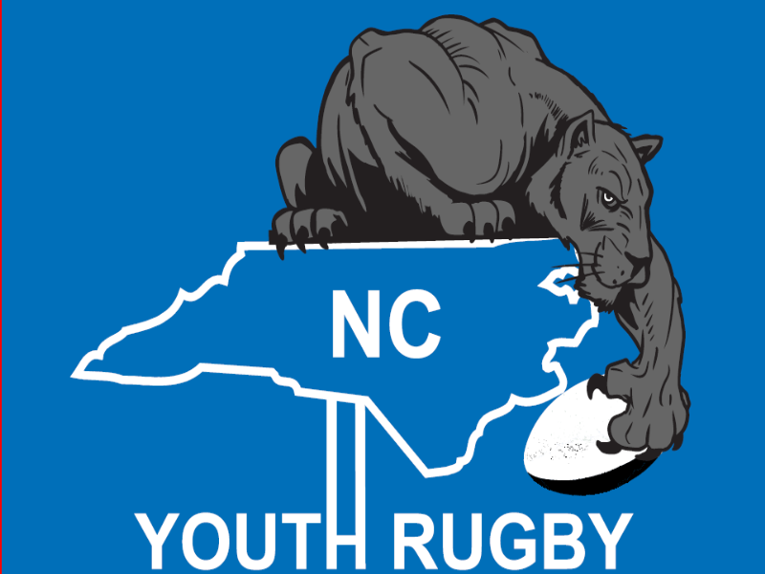

Members in attendance: Carl Hamm, Conrad Wood, Steve Grill, James Larkin, Matt Henry
Members absent: Andy Thomas
- Attendance at the Youth Conference in California in January (Jan 18-20, 2013).
USA Rugby will provide the airfare and accommodation for one member of the SBRO to attend the annual youth conference in California. If there is a second person who will wish to attend on behalf of NC SBRO, NCYRU will look at helping with costs for that individual. “The 2013 National Development Summit brings best practices in rugby development for all coaches, referees, and administrators around the country.” – visit their site for more details. http://usarugby.wildapricot.org/

- Rugby Festival update – March 9-10, 2013.
Ramon is heading up the Rugby Festival committee and has sent out invitations to as many HS teams as possible. The venue at Elon Park has been booked and a second location is being considered – either Ardrey Kell HS or Community House MS.
The College exhibition game will again occur on the Saturday evening. Teams and location of the game are yet to be decided.

3). Spring Competition -- all leagues
James will work with NCHSRA and Steve McReavy/Robert Joseph to finalize teams and schedules for 2013.

4). Referees
It was proposed that Grant, PJ and Riaan continue to schedule all the referees for youth rugby matches.
Motion – passed
Discussion about young refs officiating games that they were not previously part of (i.e. if a ref played for a affiliated HS team – they would ref HS club rugby).
5). Mini -tournaments –
First two weekends of December - East Meck - XV's and West 7's also South Meck tournament in January.

6) Let's all CIPP and participate;

7) Input from officers;

8) Conclusion – 8:37pm – Next meeting - Monday, November 19, 2012 7:30 PM-8:30 PM.

